Home Work 4: Oracle SQL Class

Research
In your own words give a brief definition of CRUD as it relates to databases.
CRUD is the process of creating, reading, updating and deleting data or tables in a database.

In your own words give a brief definition of ACID as it relates to databases.
Atomicity - Each transaction is required to be all or nothing. If a single part fails, all of the transaction fails and the data is unchanged.
Consistency - All data written to a database must be valid according to the rules(constraints,etc.) of the database.
Isolation - The concurrent execution of transactions results in a system state that would be obtained if the transactions were ran one after another.
Durability - Once a transaction has been committed, it will remain that way despite anything that happens afterward.

In your own words give a brief definition of Atomicity as it relates to databases.
Atomicity - Each transaction is required to be all or nothing. If a single part fails, all of the transaction fails and the data is unchanged.

In your own words give a brief definition of Drilling Down as it relates to databases.
Going more granular (deeper level) in the detail of the data.

In your own words give a brief definition of Granularity as it relates to databases.
Getting more detail of the data hierarchy.

DECODE

SCORES
Student_id | Score
2122 | 54
3211 | 92
411 | 80
2771 | 77
2098 | 64
7890 | 0

Create a table called scores.
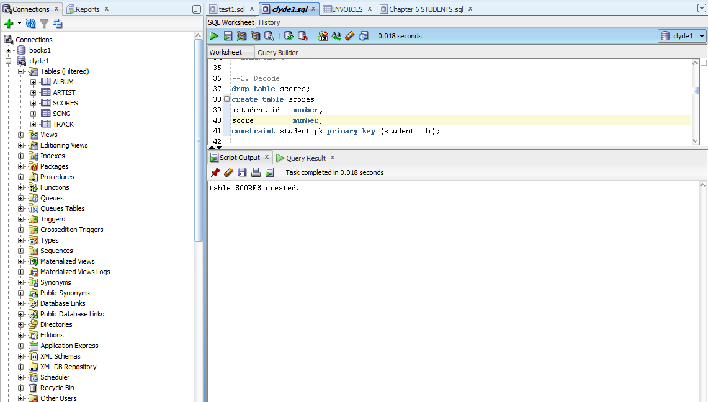

Enter the data above.
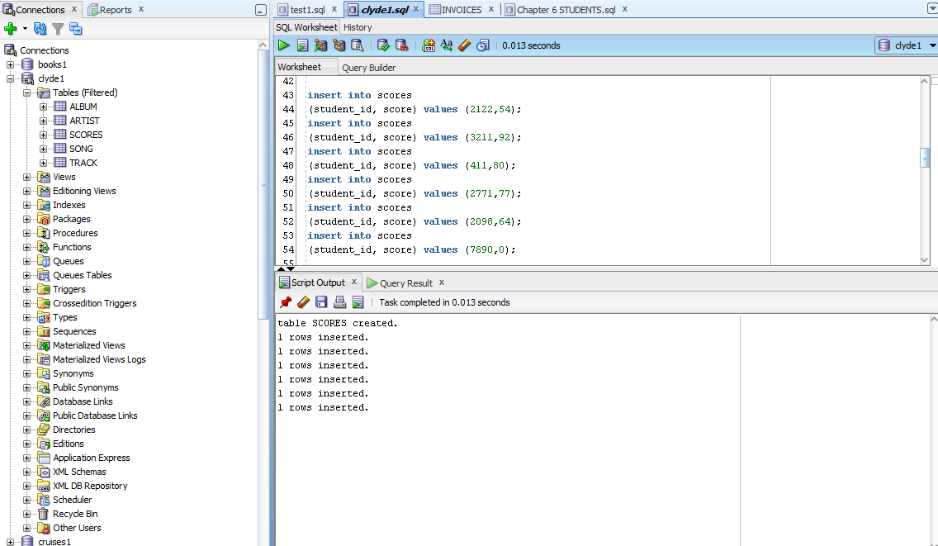

Write a SQL statement using the decode function from Chapter 6 that gives a result set showing:
Student_id
Score
Letter Grade
Where the letter grade is A if score 90-100; B if score 80-89;
C if score 70-79; D if score 60-69; INC if score 0-59;

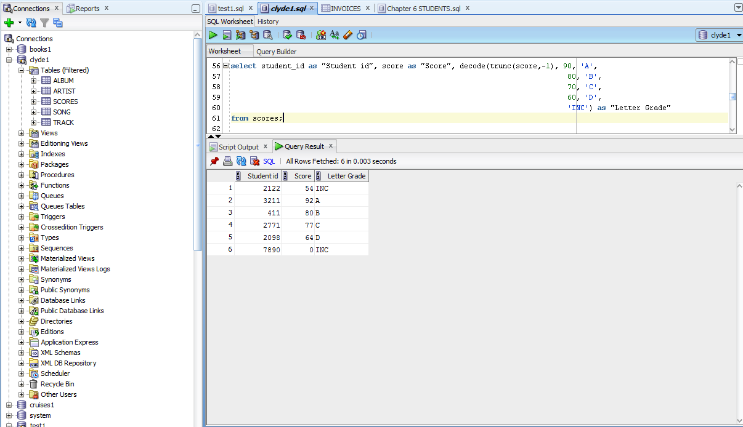

Transform null
Using Orders table in Books, write a SQL statement that returns “Not Shipped” if the shipdate is null.

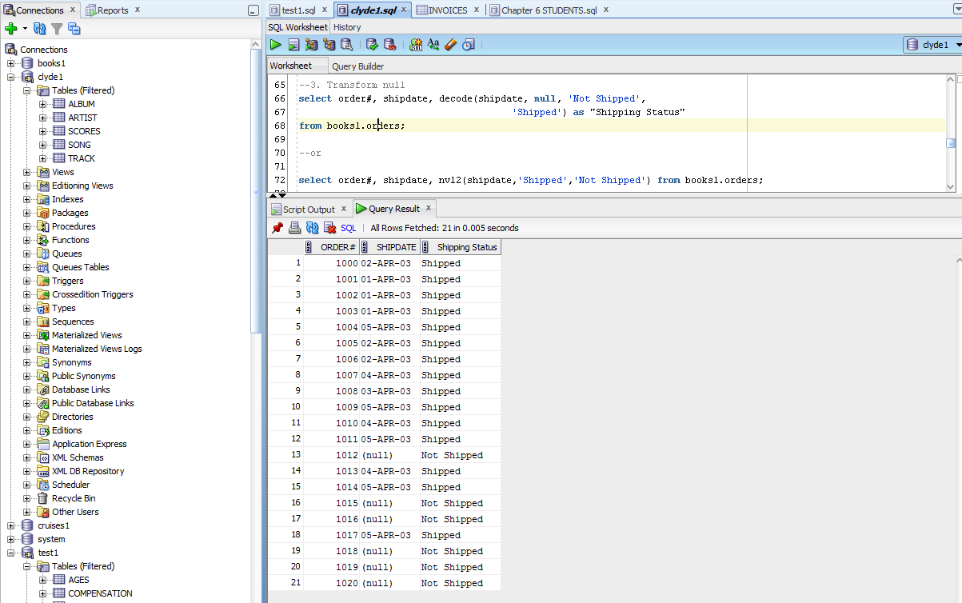

Transform date, number
Create a table called invoices and insert the following rows. In the insert statement use
to_date to change string ‘3/15/2009’ to a date
to_number to change string ‘147119’ to a number

INVOICES
Inv_id | inv_date | inv_amt | Acct_no
701 | 3/15/2009 | 147119 | 0CODDA15
702 | 6/17/2010 | 275803 | CODDA12
703 | 10/18/2010 | 248414 | CODDA20
704 | 1/19/2009 | 169206 | CODDA18
705 | 9/18/2011 | 102680 | CODDA12
706 | 11/4/2010 | 179138 | CODDA17
707 | 12/13/2011 | 270723 | CODDA18
708 | 9/15/2010 | 130288 | CODDA13
709 | 3/21/2010 | 255003 | CODDA18
710 | 4/13/2009 | 254837 | CODDA19
711 | 6/30/2010 | 284695 | CODDA19
712 | 11/20/2010 | 297928 | CODDA19

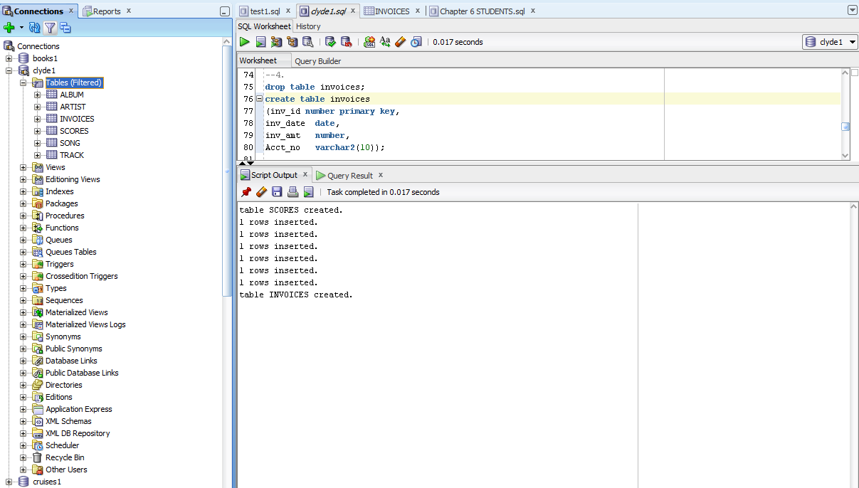

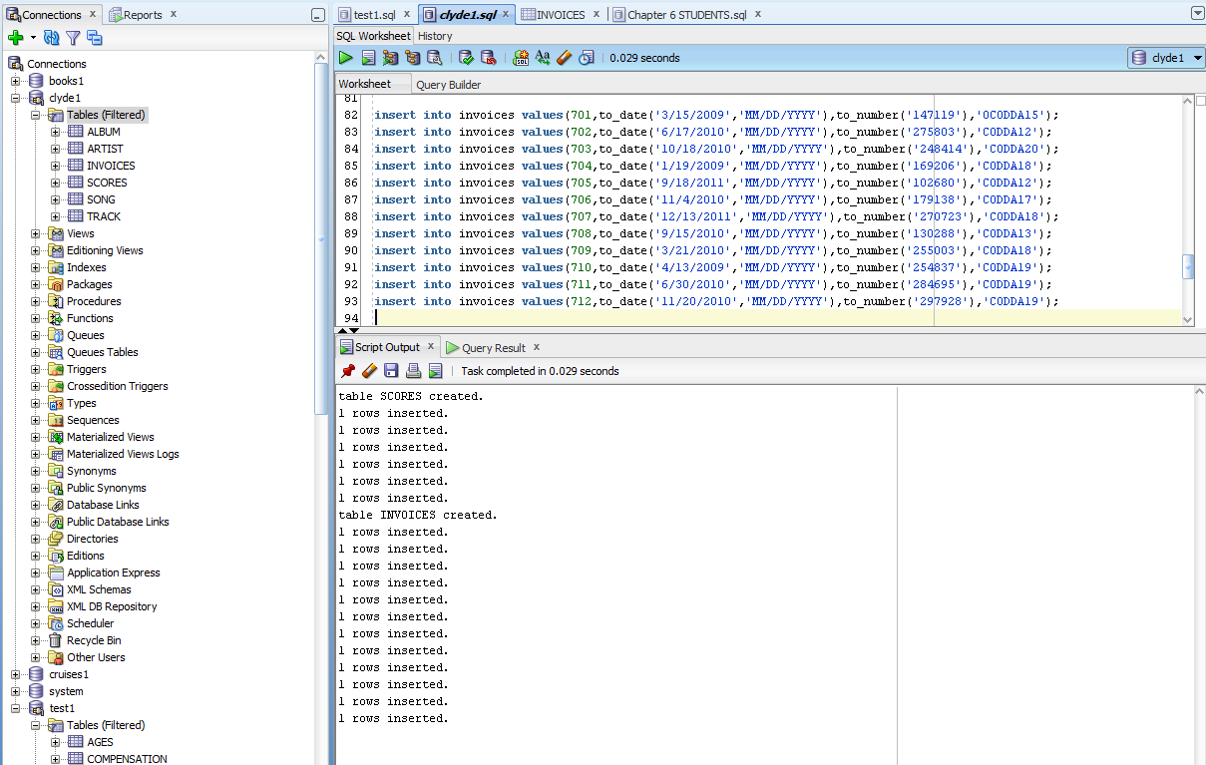

Case Statement
Create a SQL case statement that returns all table columns with one additional column that states
Add Invoice to 2009 if the invoice date is in 2009
Add Invoice to 2010 if the invoice date is in 2010
Add Invoice to 2011 if the invoice date is in 2011
